Instructions and Formatting Rules for Authors of National Conference on Sustainable Development in Electrical & Computer Engineering

FirstName A.LastName1, FirstName B. LastName2

1- Name of Institution/Department, City, Country.

Email: first.author@hostname1.org (Corresponding author)

2- Name of Institution/Department, City, Country.

Email: [second.author@hostname2.org](mailto:second.author@hostname2.org)

**ABSTRACT:**

Basic guidelines for the preparation of a technical work for the this conference are presented. This document is itself an example of the desired layout (inclusive of this abstract) and can be used as a template. The document contains information regarding desktop publishing format, type sizes, and typefaces. Style rules are provided, which explain how to handle equations, units, figures, tables, abbreviations, and acronyms. Sections are also devoted to the preparation of acknowledgments, appendices and references. The abstract is limited to 250 words, and cannot contain equations, figures, tables, or references. It should concisely state what was done, how it was done, principal results, and their significance.

**KEYWORDS:**The author shall provide up to 10 keywords to help identify the major topics of the paper.

Introduction

This document provides an example of the desired layout for a MJEE journal paper and can be used as a template for Microsoft Word versions 2003. It contains information regarding desktop publishing format, type sizes, and typefaces. Style rules are provided to explain how to handle equations, units, figures, tables, abbreviations, and acronyms. Sections are also devoted to the preparation of appendixes, acknowledgments, references, and authors’ biographies. For additional information including electronic file requirements for text and graphics, please refer to [www.mjee.org](http://www.mjee.org).

# Technical Work Preparation

Please use automatic hyphenation and check your spelling. Additionally, be sure your sentences are complete and that there is continuity within your paragraphs. Check the numbering of your graphics and make sure that all appropriate references are included.

## Template

This document may be used as a template for preparing your technical work. When you open the file, select "Print Layout" from the "View" menu (View | Print Layout), which allows you to see the footnotes. You may then type over sections of the document, cut and paste into it (Edit | Paste Special | Unformatted Text), and/or use markup styles. The pull-down style menu is at the left of the Formatting Toolbar at the top of your Word window.

In order to format your paper:

1- Highlight a section that you want to designate with acertain style (Fig.1)

2- select the appropriate “MJEE style”from the pull down style menu (MJEE different styles are defined to different parts of the paper).E.g. to format the abstract text choose “MJEE abstract”(Fig.2).

## Format

If you choose not to use this document as a template, prepare your technical work in single-spaced, double-column format, on paper 21.8×28.8 centimeters (8.58×11.33 inches. Set top and bottom margins to 2.5 millimeters and left and right margins to about 2.5 millimeters. Do not violate margins (i.e., text, tables, figures, and equations may not extend into the margins). The column width is 7.9 millimeters. The space between the two columns is 1 centimeter. Paragraph indentation is 1 centimeter. Use full justification. Use either one or two spaces between sections, and between text and tables or figures, to adjust the column length.

## Typefaces and Sizes

Please use a proportional serif typeface such as Times Roman or Times New Roman and embed all fonts. Table 1 provides samples of the appropriate type sizes and styles to use.

**Table 1.**Samples of times roman type sizes and styles used for formatting a technical work.

|  |  |  |
| --- | --- | --- |
| Point  Size | Purpose in Paper | Special  Appearance |
|  | Author affiliation, |  |
|  | table text |  |
|  | figure text |  |
|  | endnotes |  |
|  | subscripts,  superscripts |  |
|  | References. |  |
|  | Abstract, keywords,  figure caption | Table Title |
|  | Body text, equations | Subheadings  Section Titles |
|  | Author Name |  |
| 18B |  | Title |

## Section Headings

A primary section heading is enumerated by a Roman numeral followed by a period and is centered above the text. A primary heading should be in capital letters.

A secondary section heading is enumerated by a capital letter followed by a period and is flush left above the section. The first letter of each important word is capitalized and the heading is italicized.

A tertiary section heading is enumerated by an Arabic numeral followed by a parenthesis. It is indented and is followed by a colon. The first letter of each important word is capitalized and the heading is italicized.

A quaternary section heading is rarely necessary, but is perfectly acceptable if required. It is enumerated by a lowercase letter followed by a parenthesis. It is indented and is followed by a colon. Only the first letter of the heading is capitalized and the heading is italicized.

## Figures and Tables

Figure axis labels are often a source of confusion. Try to use words rather than symbols. As an example, write the quantity "Magnetization," or "Magnetization, M," not just "M." Put units in parentheses. Do not label axes only with units. As in Figure 1, write "Magnetization (kA/m)" or "Magnetization (kA·m-1)," not just "kA/m." Do not label axes with a ratio of quantities and units. For example, write "Temperature (K)," not "Temperature/K." Figure labels should be legible, approximately 8- to 10-point type.

Large figures and tables may span both columns, but may not extend into the page margins. Arrange these one column figures and tables at either top or end of a page, or at the end of the paper right before the references. Figure captions should be below the figures; table captions should be above the tables. Do not put captions in "text boxes" linked to the figures. Do not put borders around your figures. Use Insert | Reference | Caption to number your tables and figures, and use Insert | Reference | Cross- reference to refer to their numbers.

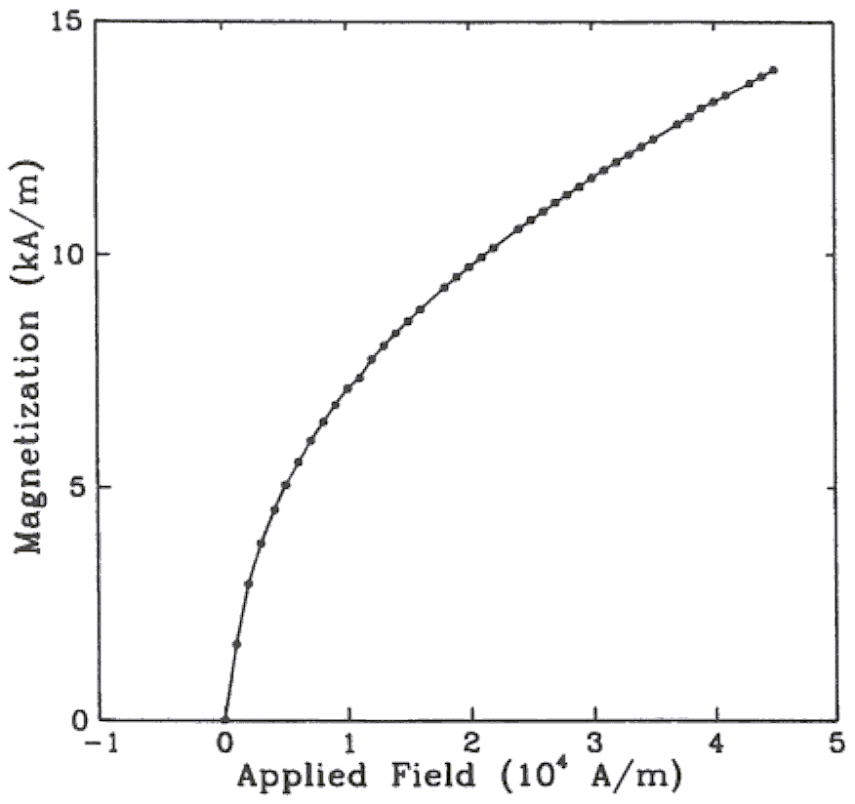

**Fig.1**. Magnetization as a function of applied field. (Note that there is a colon after the figure number followed by two spaces.)

All figures and tables must appear near, but not before, their first mention in the text. Use the abbreviation "Fig. 1," even at the beginning of a sentence.

To insert images in Word, use Insert | Picture | From File.

## Numbering

Number reference citations consecutively in square brackets [1]. The sentence punctuation follows the brackets [2]. Multiple references [2], [3] are each numbered with separate brackets [1]-[3]. Refer simply to the reference number, as in [3]. Do not use "Ref. [3]" or "reference [3]" except at the beginning of a sentence: "Reference [3] shows…."

Number footnotes separately with superscripts (Insert | Footnote). Place the actual footnote at the bottom of the column in which it is cited. Do not put footnotes in the reference list. Use letters for table footnotes.

Use Arabic numerals for figures and Roman numerals for tables. Appendix figures and tables should be numbered consecutively with the figures and tables appearing in the rest of the paper. They should not have their own numbering system.

## Units

Metric units are preferred for use in IEEE publications in light of their global readership and the inherent convenience of these units in many fields. In particular, the use of the International System of Units is advocated. This system includes a subsystem of units based on the meter, kilogram, second, and ampere (MKSA). British units may be used as secondary units (in parentheses). An exception is when British units are used as identifiers in trade, such as 3.5-inch disk drive.

## Abbreviations and Acronyms

Define less common abbreviations and acronyms the first time they are used in the text, even after they have been defined in the abstract. Abbreviations such as IEEE, SI, MKS, CGS, ac, dc, and rms do not have to be defined. Do not use abbreviations in the title unless they are unavoidable.

## Math and Equations

Number equations consecutively with equation numbers in parentheses flush with the right margin, as in (1). First use the equation editor to create the equation. Then select the “Equation” markup style. Write the equation number in parentheses using Insert | Caption.

Use the Microsoft Equation Editor for all math objects in your paper (Insert | Object | Create New | Microsoft Equation or MathType Equation). "Float over text" should not be selected.

To make your equations more compact, you may use the slash ( / ), the exp function, or appropriate exponents. Italicize Roman symbols for quantities and variables, but not Greek symbols. Use a long dash rather than a hyphen for a minus sign. Use parentheses to avoid ambiguities in denominators. Punctuate equations when they are part of a sentence, as in

()

Number equations consecutively with equation numbers in parentheses flush with the right margin, as in (1). Be sure that the symbols in your equation have been defined before the equation appears or immediately following. Italicize symbols (T might refer to temperature, but T is the unit Tesla). Use Insert | Reference | Caption to number equations. Refer to “(1),” not “Eq. (1)” or “equation (1),” except at the beginning of a sentence: “Equation (1) is ...”. Use two column tables to locate equations and their numbers properly in one line, as follows:

 (2)

where IF is the fault current. Be sure that the border is off.

# Appendix

Appendixes, if needed, appear before the acknowledgment. Subsections for this part also should be numbered by alphabets.

# Nomenclature

A nomenclature list, if needed, should precede the Appendixes.

# Acknowledgment

The following is an example of an acknowledgment. (Please note that financial support should be acknowledged in the unnumbered footnote on the title page.)

The author gratefully acknowledges the IEEE I. X. Austan, A. H. Burgmeyer, C. J. Essel, and S. H. Gold for their work on the original version of this document.

References are important to the reader; therefore, each citation must be complete and correct. There is no editorial check on references; therefore, an incomplete or wrong reference will be published unless caught by a reviewer or discusser and will detract from the authority and value of the paper. References should be readily available publications.

List only one reference per reference number. If a reference is available from two sources, each should be listed as a separate reference. Give all authors' names; do not use et al.

Samples of the correct formats for various types of references are given below.

**REFERENCES**

J. F. Fuller, E. F. Fuchs, and K. J. Roesler, **“Influence of harmonics on power distribution system protection, ”***IEEE Trans. Power Delivery,* vol. 3, pp. 549-557, Apr. 1988.

E. H. Miller, **“A note on reflector arrays, ”***IEEE Trans. Antennas Propagat*., to be published.

R. J. Vidmar. (1992, Aug.). On the use of atmospheric plasmas as electromagnetic reflectors. IEEE Trans. Plasma Sci. [Online]. 21(3), pp. 876-880. Available:

<http://www.halcyon.com/pub/journals/21ps03-vidmar>

E. Clarke, Circuit Analysis of AC Power Systems, vol. I. New York: Wiley, 1950, p. 81.

G. O. Young, **“Synthetic structure of industrial plastics, ”** in *Plastics, 2nd ed*., vol. 3, J. Peters, Ed. New York: McGraw-Hill, 1964, pp. 15-64.

J. Jones. (1991, May 10). Networks. (2nd ed.) [Online]. Available: <http://www.atm.com>

E. E. Reber, R. L. Mitchell, and C. J. Carter, **“Oxygen absorption in the Earth's atmosphere,”***Aerospace Corp.*, Los Angeles, CA, Tech. Rep. TR-0200 (4230-46)-3, Nov. 1968.

S. L. Talleen. (1996, Apr.). The Intranet Architecture: Managing information in the new paradigm. Amdahl Corp., Sunnyvale, CA. [Online]. Available: http://www.amdahl.com/doc/products/bsg/intra/ infra/html

D. Ebehard and E. Voges, **“Digital single sideband detection for interferometric sensors, ”** presented at the *2nd Int. Conf. Optical Fiber Sensors*, Stuttgart, Germany, 1984.

Process Corp., Framingham, MA. Intranets: Internet technologies deployed behind the firewall for corporate productivity. Presented at INET96 Annu. Meeting. [Online]. Available: http://home.process.com/ Intranets/wp2.htp

J. L. Alqueres and J. C. Praca, **“The Brazilian power system and the challenge of the Amazon transmission,”***in Proc. 1991 IEEE Power Engineering Society Transmission and Distribution Conf.*, pp. 315-320.

S. Hwang, **“Frequency domain system identification of helicopter rotor dynamics incorporating models with time periodic coefficients, ”** Ph.D. dissertation, Dept. Aerosp. Eng., Univ. Maryland, College Park, 1997.

*IEEE Guide for Application of Power Apparatus Bushings,* IEEE Standard C57.19.100-1995, Aug. 1995.

G. Brandli and M. Dick, **“Alternating current fed power supply, ”** U.S. Patent 4 084 217, Nov. 4, 1978.